Data Definition:
Based on acoustic features of the voice and speech, this database was constructed to determine if a voice is male or female. The collection includes 3,168 recorded speech samples from male and female speakers. Acoustic analysis in R utilizing the seewave and tuneR packages is used to pre-process the voice samples, with an analyzed frequency range of 0hz-280hz (human vocal range).

Dataset:
The following acoustic properties (20 features) of each voice are measured and included within the CSV:
- meanfreq: mean frequency (in kHz)
- sd: standard deviation of frequency
- median: median frequency (in kHz)
- Q25: first quantile (in kHz)
- Q75: third quantile (in kHz)
- IQR: interquantile range (in kHz)
- skew: skewness (see note in specprop description)
- kurt: kurtosis (see note in specprop description)
- sp.ent: spectral entropy
- sfm: spectral flatness
- mode: mode frequency
- centroid: frequency centroid (see specprop)
- peakf: peak frequency (frequency with highest energy)
- meanfun: average of fundamental frequency measured across acoustic signal
- minfun: minimum fundamental frequency measured across acoustic signal
- maxfun: maximum fundamental frequency measured across acoustic signal
- meandom: average of dominant frequency measured across acoustic signal
- mindom: minimum of dominant frequency measured across acoustic signal
- maxdom: maximum of dominant frequency measured across acoustic signal
- dfrange: range of dominant frequency measured across acoustic signal
- modindx: modulation index. Calculated as the accumulated absolute difference between adjacent measurements of fundamental frequencies divided by the frequency range
- label: male or female

All data is float, except the label, which is an object with value ‘male’ or ‘female’. .

The data was not bias, and both male and female data were equal.
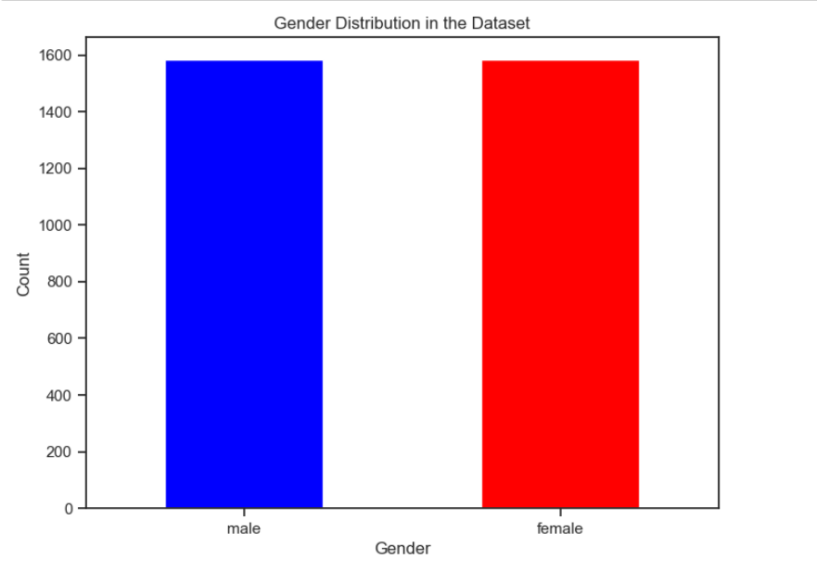
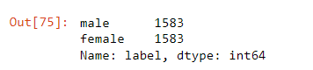

The data had no missing values that it was needed to deal with
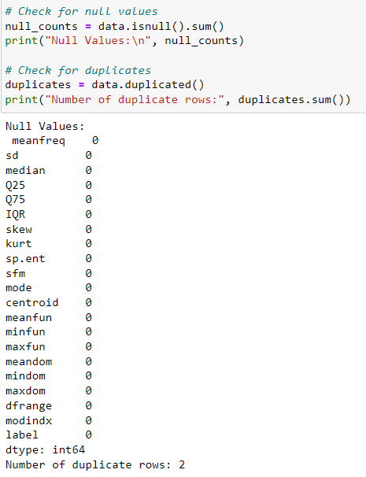
There were only 2 duplicate records, and thus were removed

Data Visualization:

data was checked for outliers as well. But since voice properties like frequency can vary greatly between individuals, it was decided not to get rid of any outliers.
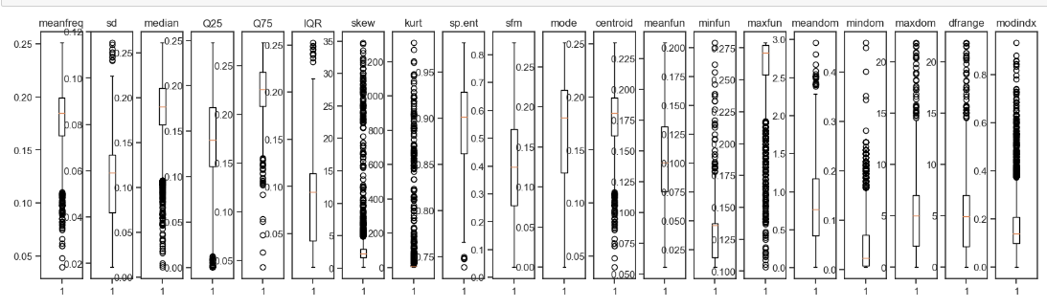

Sample of how the features are distributed via histograms
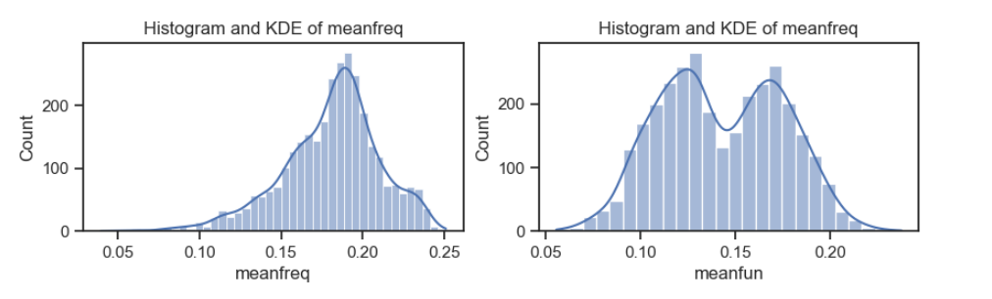

a visualization of the univariate distributions using kernel density estimation to see which traits best distinguish males from females:
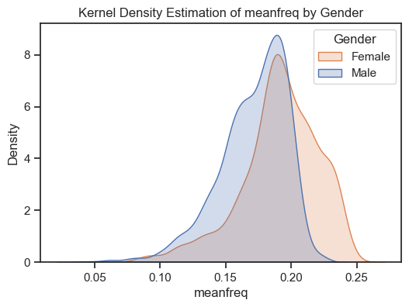
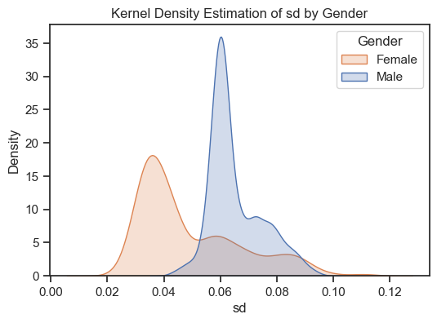
At first sight, some shown varied qualities include:'sd', 'IQR', and'meanfun'.
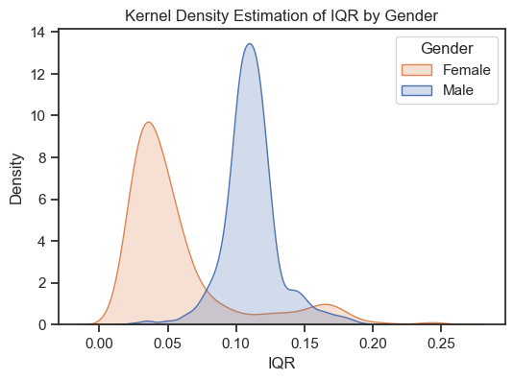
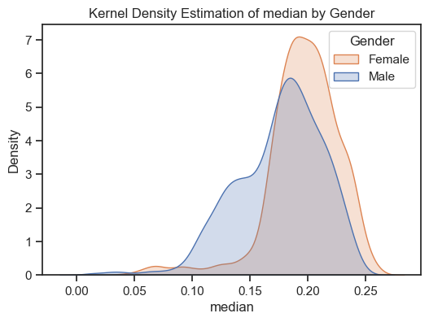

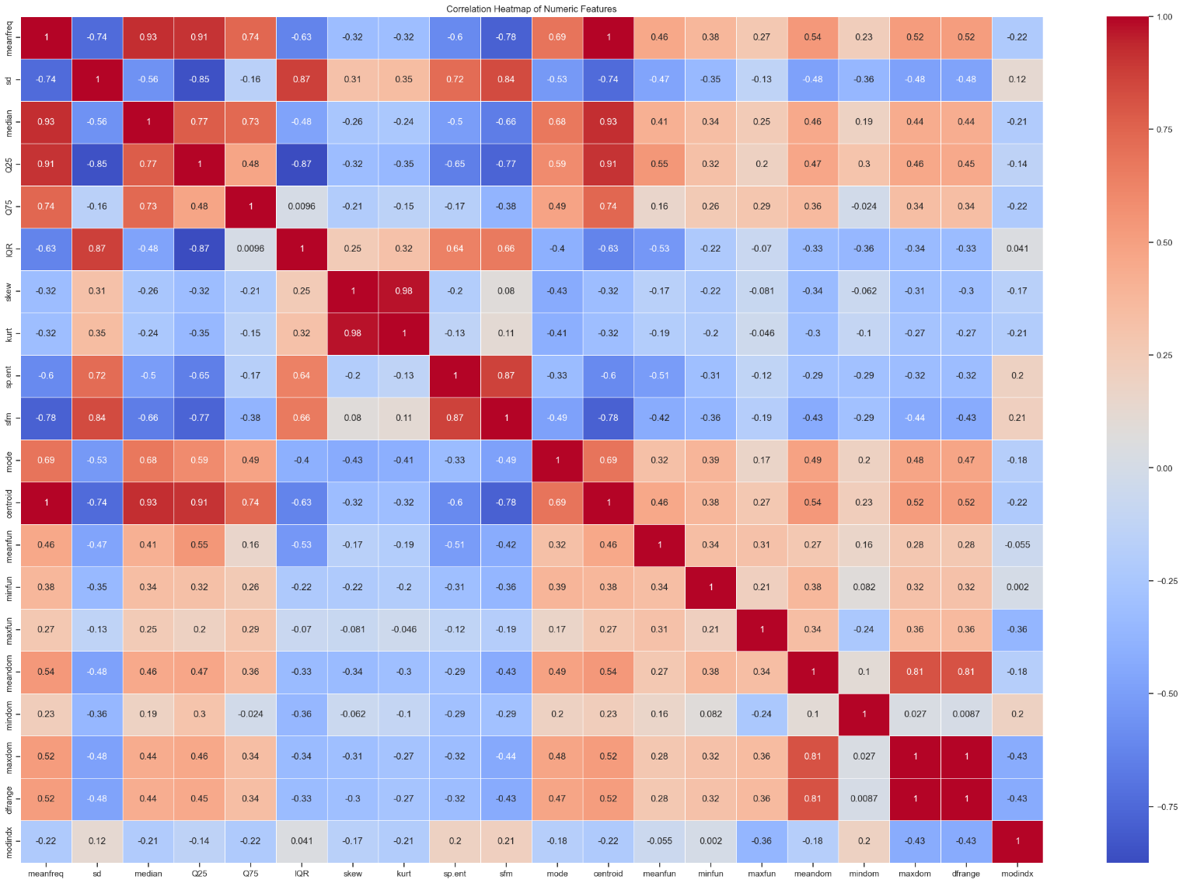
visualize the correlation matrix to see what feathers are highly correlated or not

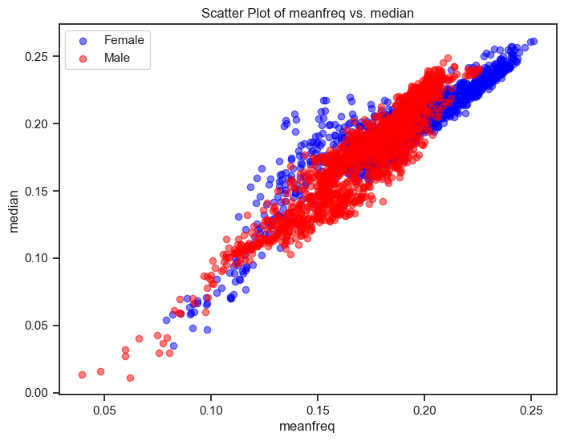
Here , is an example of 2 features plotted via scatter plot that are highly corelated ; by showing the distribution of values of each feature labeled by the Gender

Classification:

The goal is to classify the behavior of the features that only lead us to 2 classes ; Male or Female , throughout understanding those numeric frequencies and acoustics.
the 3 classification models implemented based on different performance measures were
- Decision tree
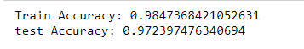
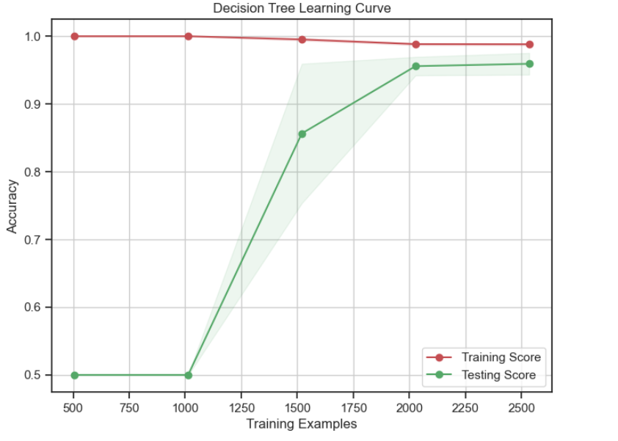
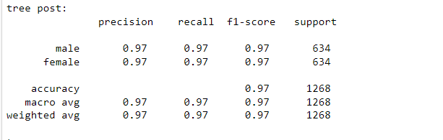
- Has the highest accuracy, precision, recall and f1-score out of all models

This confusion matrix proved that each label in the dataset has been predicted correctly
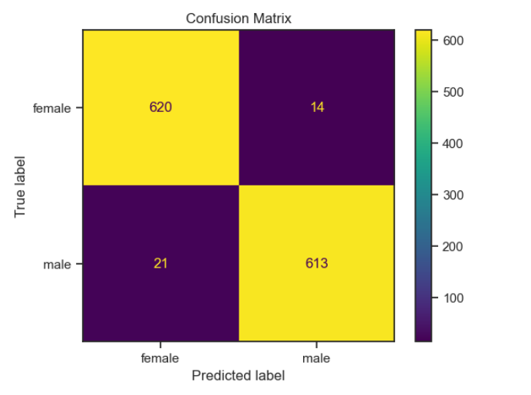

- KNN

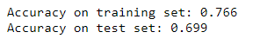

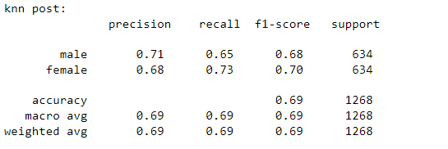
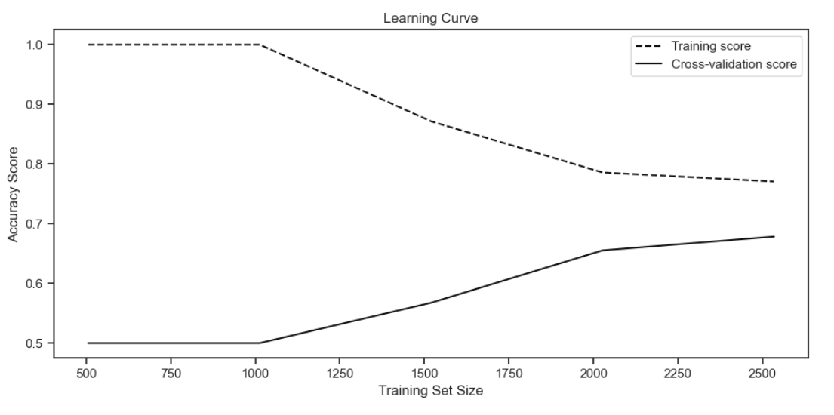

- Logistic Regression

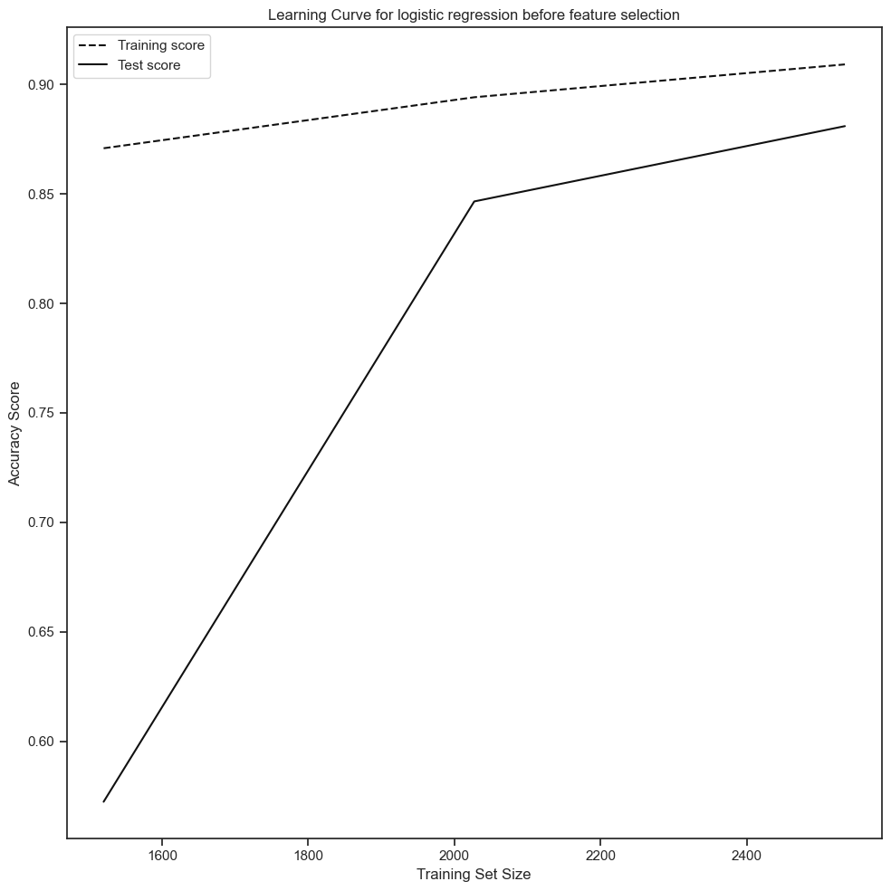

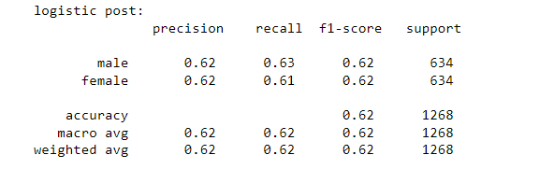

Results and analysis:

After measuring and testing , this dataset has a variation of accuricies due to a gap between the models , the decision tree is the best accuracy model
The results are shown in the below ROC. It can be seen the decision tree without feature selection had the highest AUC (Area Under Curve), and hence, decision tree is the chosen model for this classification problem

